Launch a WordPress Website in 10 minutes.

Step 1: Launch an Amazon EC2 Instance

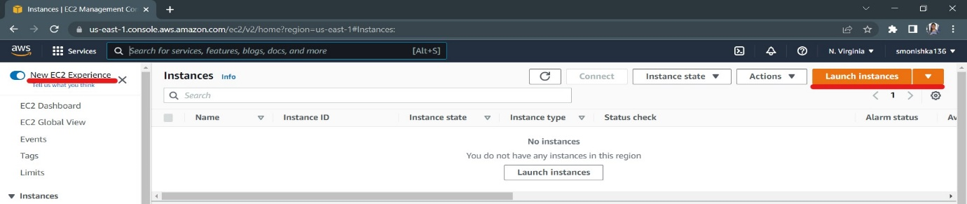

Step 2: Configure your Instance

a. Click on Amazon Web Services Marketplace on the left-hand side, search for WordPress, look for *WordPress certified by Bitnami and Automattic*, then click Select.

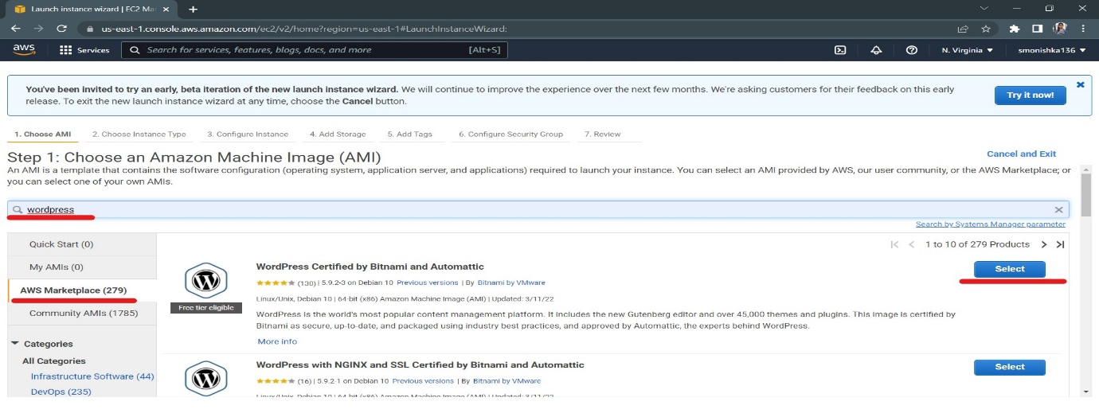

b. You will be presented a detailed pricing page. In this case, the price will be $0.00 for the software regardless of the size of the instance that you use.

Scroll to the bottom and click Continue.

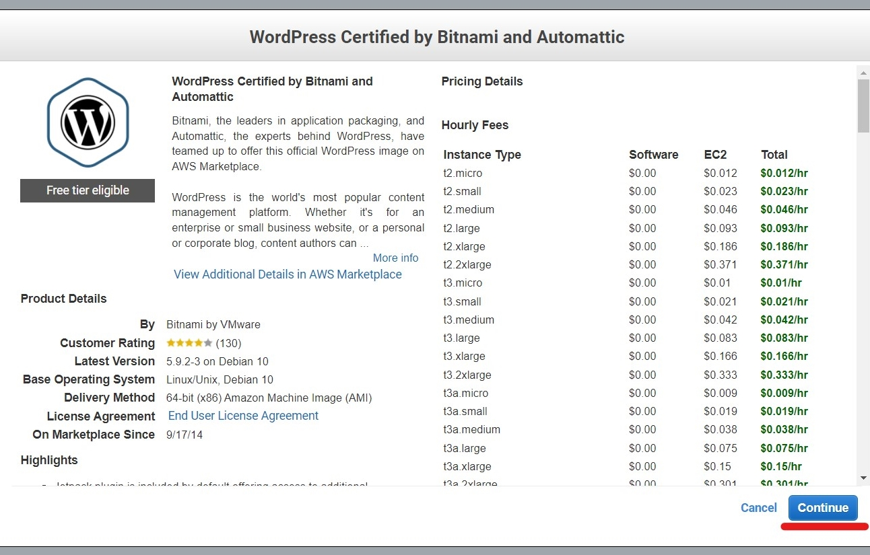

c. we will be using t2.micro instance. Click on  t2.micro in the *Type* column (it should be the first one), then click Next: Configure Instance Details. It may take a few seconds to load.

On the following screens, click Next: Add Storage and then Next: Tag Instance.

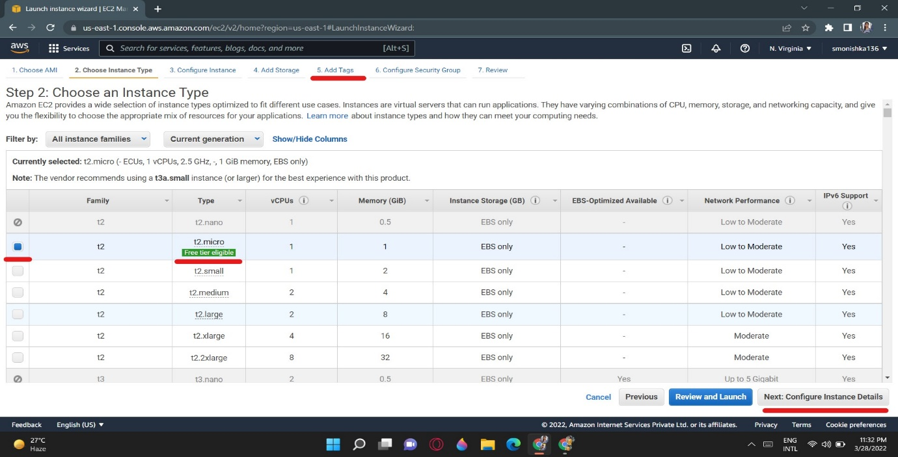

d. We will set a name for your instance in this step. Enter Name in the Key box and WordPress in the Value box. Click Review and Launch to continue.

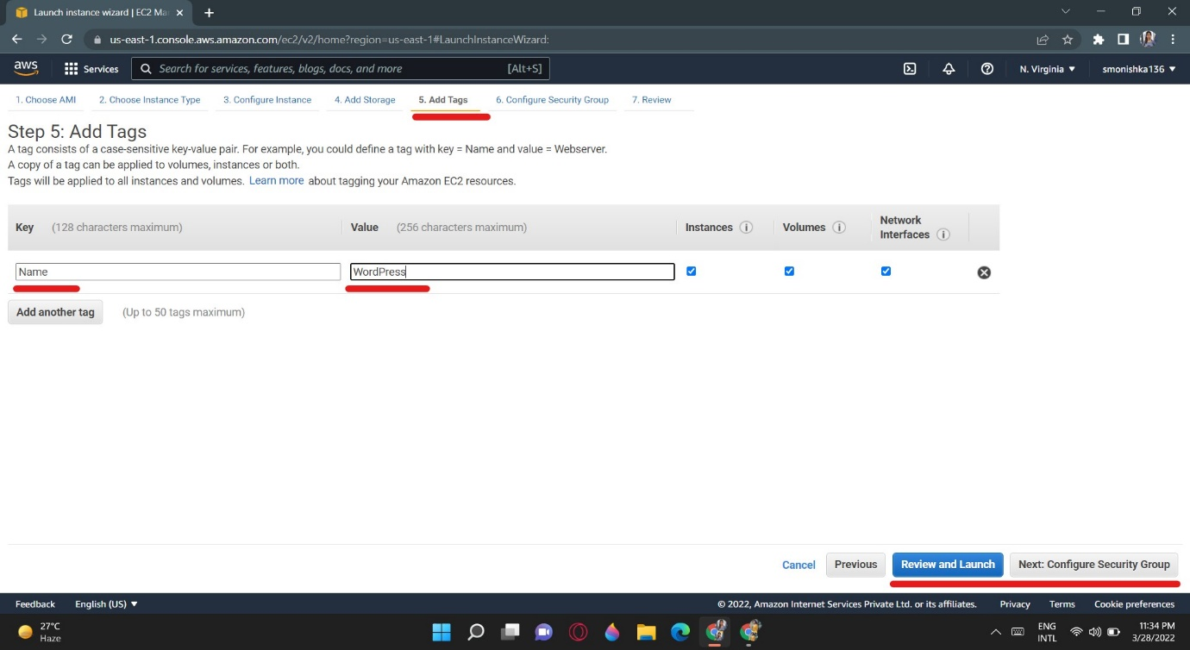

e. The next screen deals with key-pairs. Key-pairs are how you can connect to your Amazon EC2 instances via a terminal program using Secure Shell (SSH). Select Proceed without a key pair, and check the box acknowledging that you know you need this key to access your Amazon EC2 instance.

Click Launch Instances to launch your instance. Be aware that starting the instance up may take a few minutes.

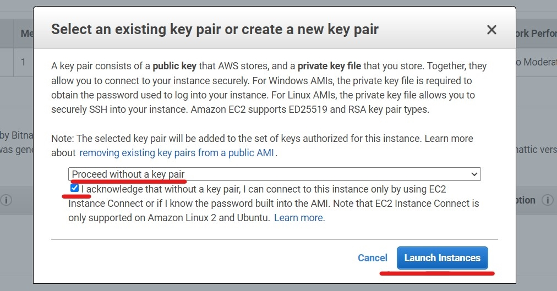

f. Click View *Instances* on the bottom right of the page (you may need to scroll down to see it).

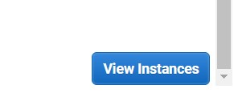

g. Then select the WordPress instance, make sure the *Instance State* says *running*. If Instance State says *launching* then Amazon Web Services is still preparing your WordPress instance .

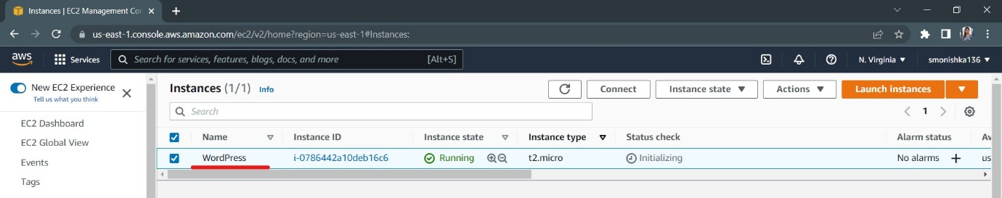

h. Once your instance is running, you can now test your WordPress website. Find the Public IP for your instance at the bottom of this page.

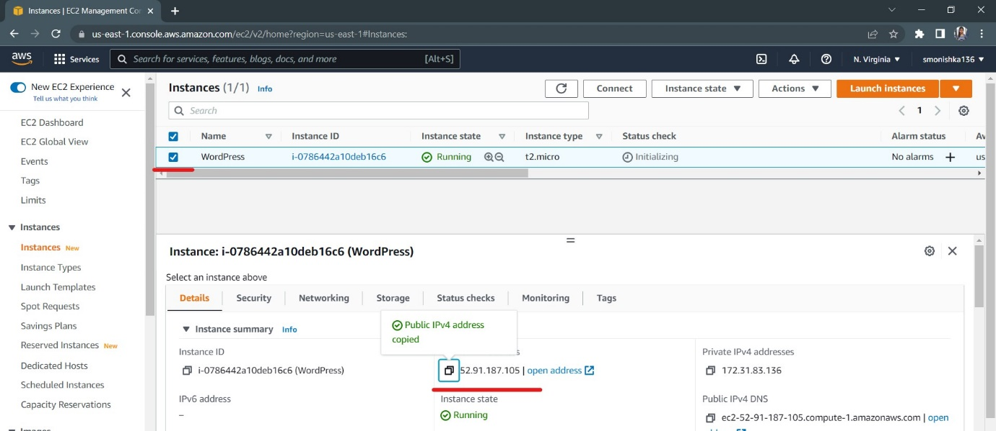

i. Copy the Public IP into a new tab in your web browser, and you should see a Hello World blog page appear.

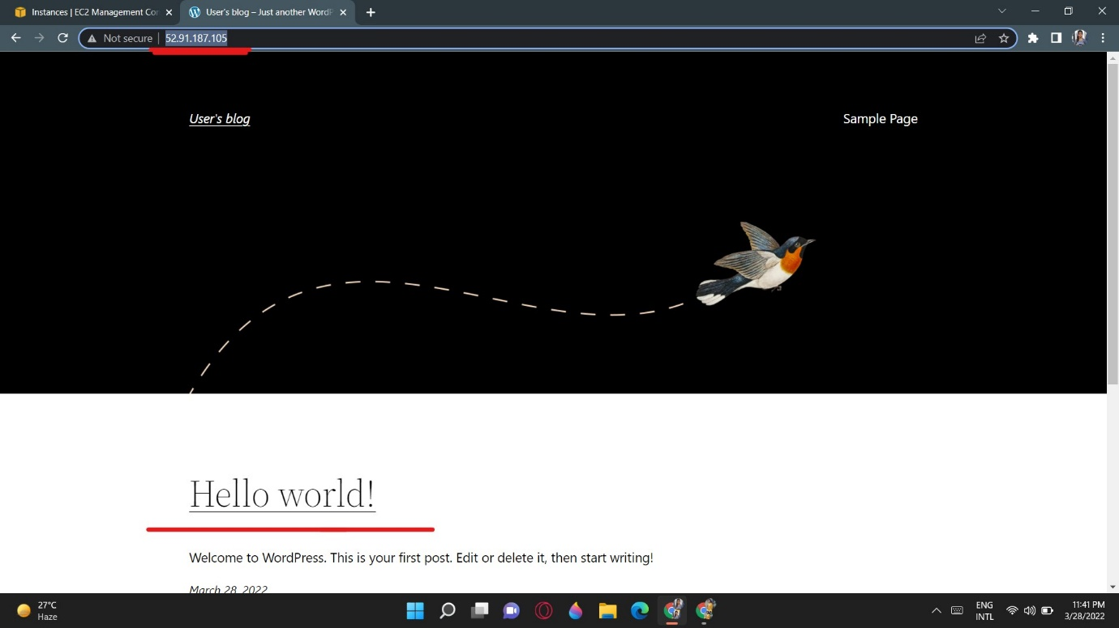

Step 3: Make Changes to Your Website

a. Switch back to your Amazon EC2 management console in your web browser. Select WordPress instance, and click the Actions button. In the drop down menu, select Monitor and troubleshoot , and choose Get System Log.

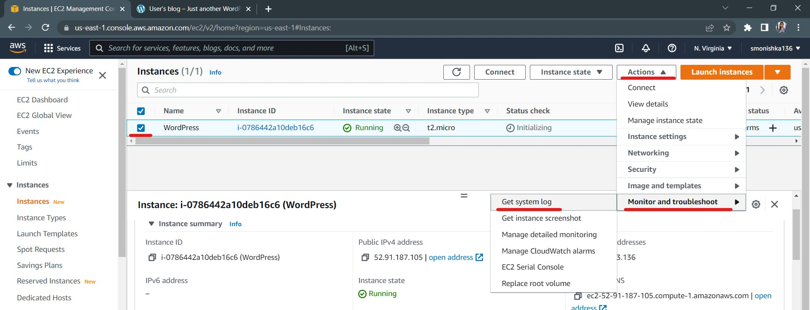

b. In the system log window, scroll through to the bottom to find the *password* that's surrounded by hash marks.

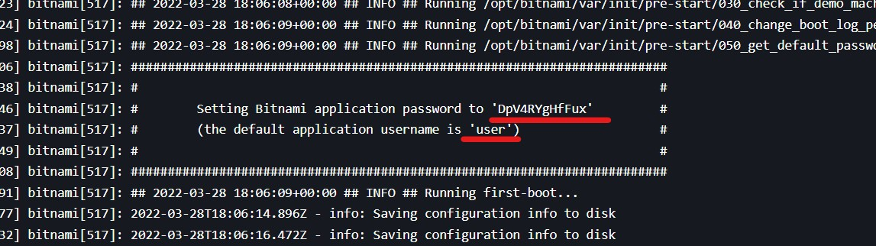

c. Now that you have your password, switch back to the tab that you used to access the WordPress Hello World page. Add /admin to the end of the URL so it looks something like 54.192.32.144/admin. Hit enter.

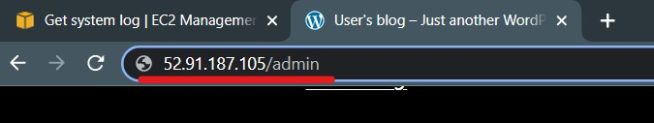

d. Enter the Username user and the Password that you read from the log file.

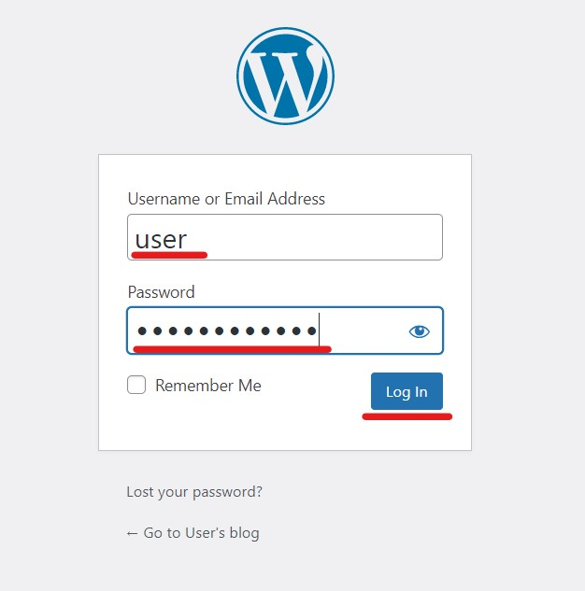

Now Finally launch WordPress site.

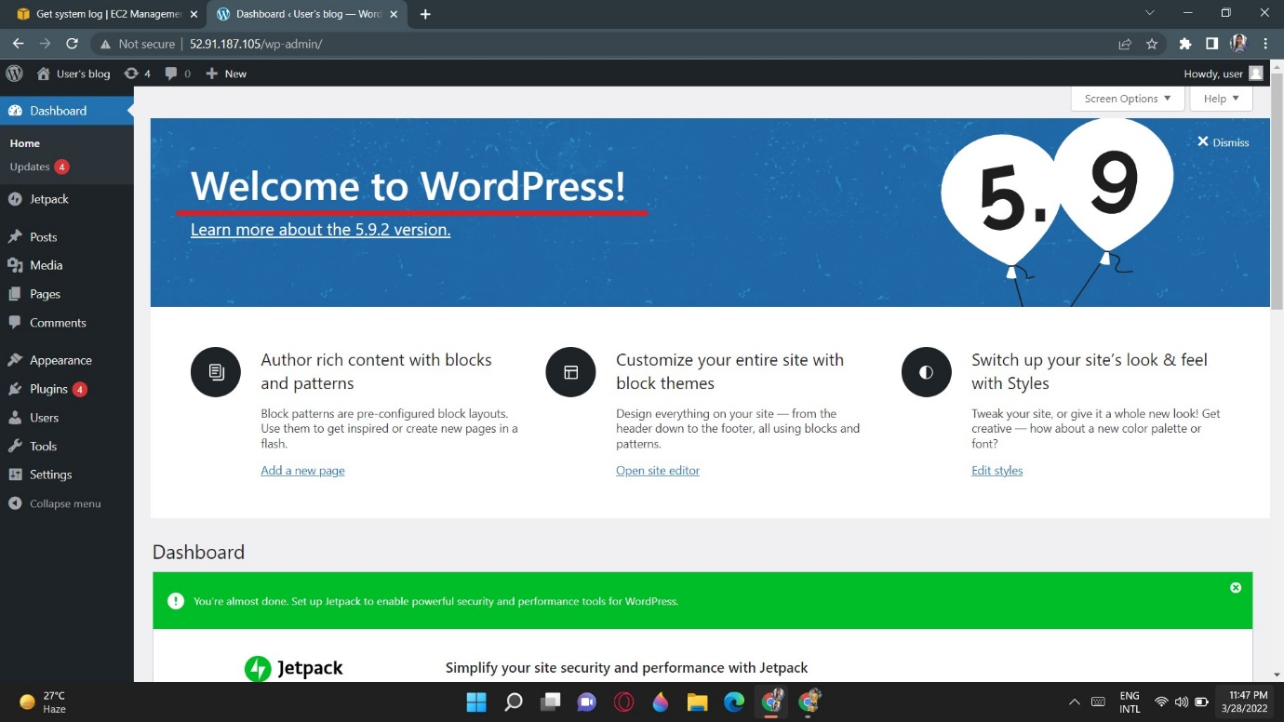

Thank You…